How to run a degree audit.

Open Wustl ONE
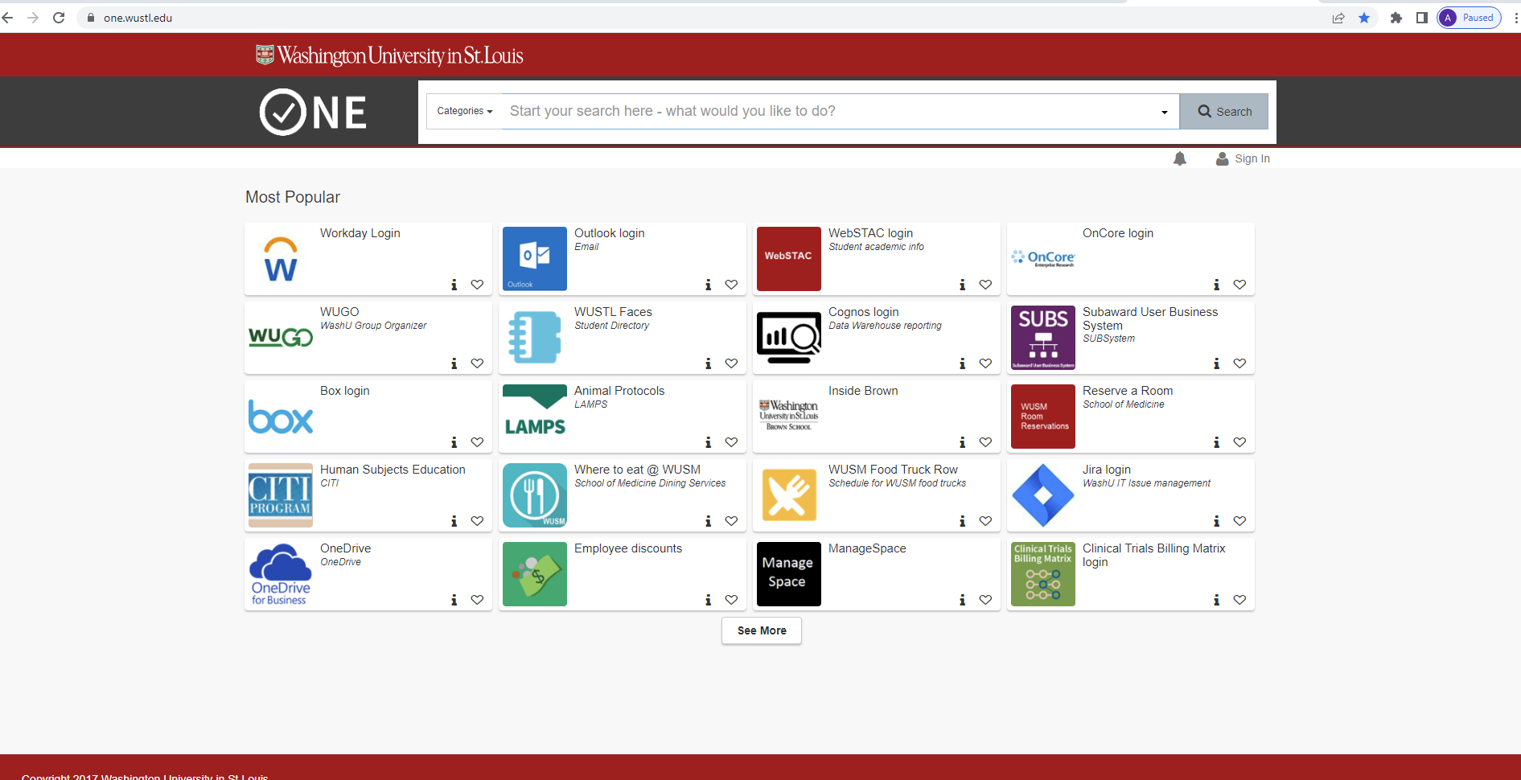

Search for “WUachieve”
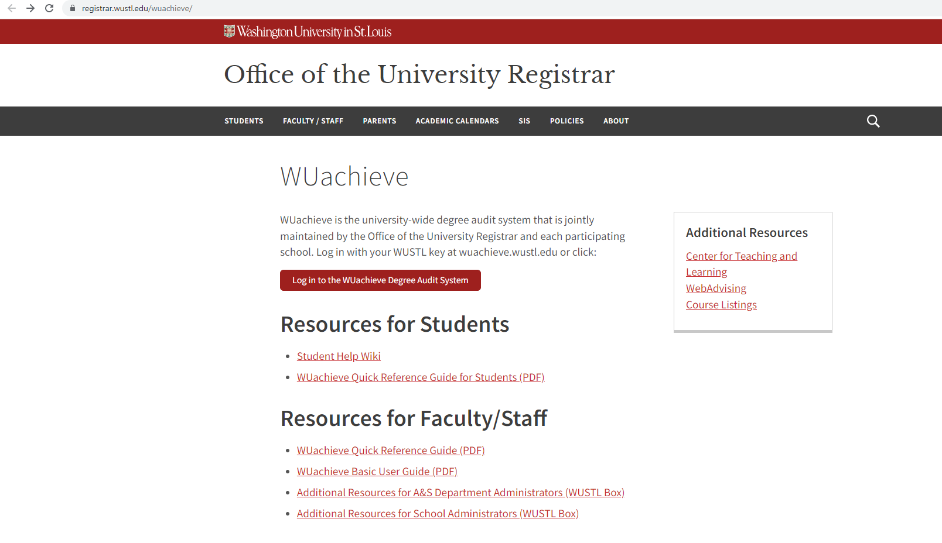

Login using your WUstl Key
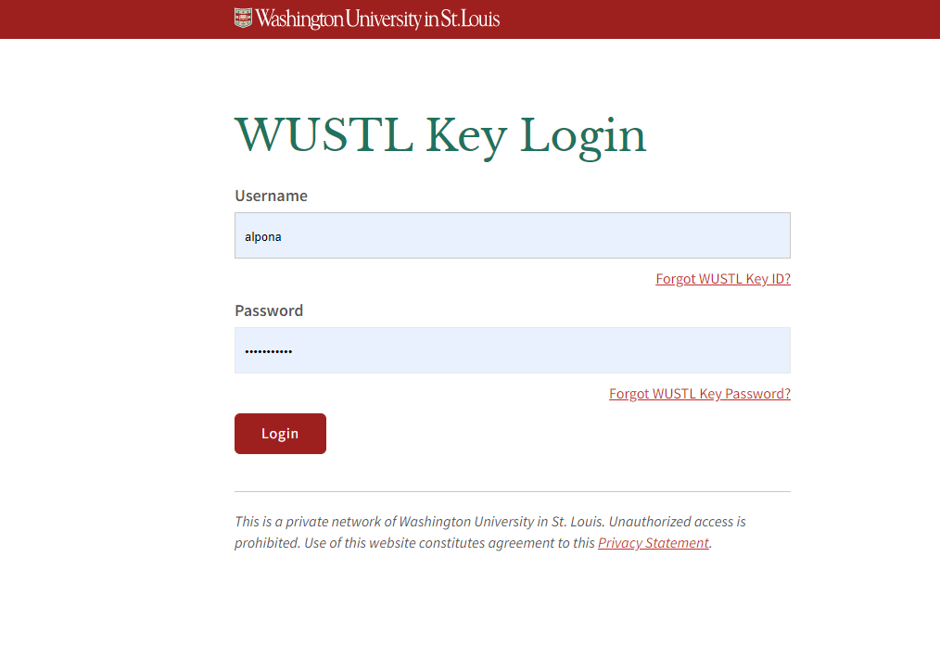
Click on the red button on the bottom left that says “Run Declared Programs”
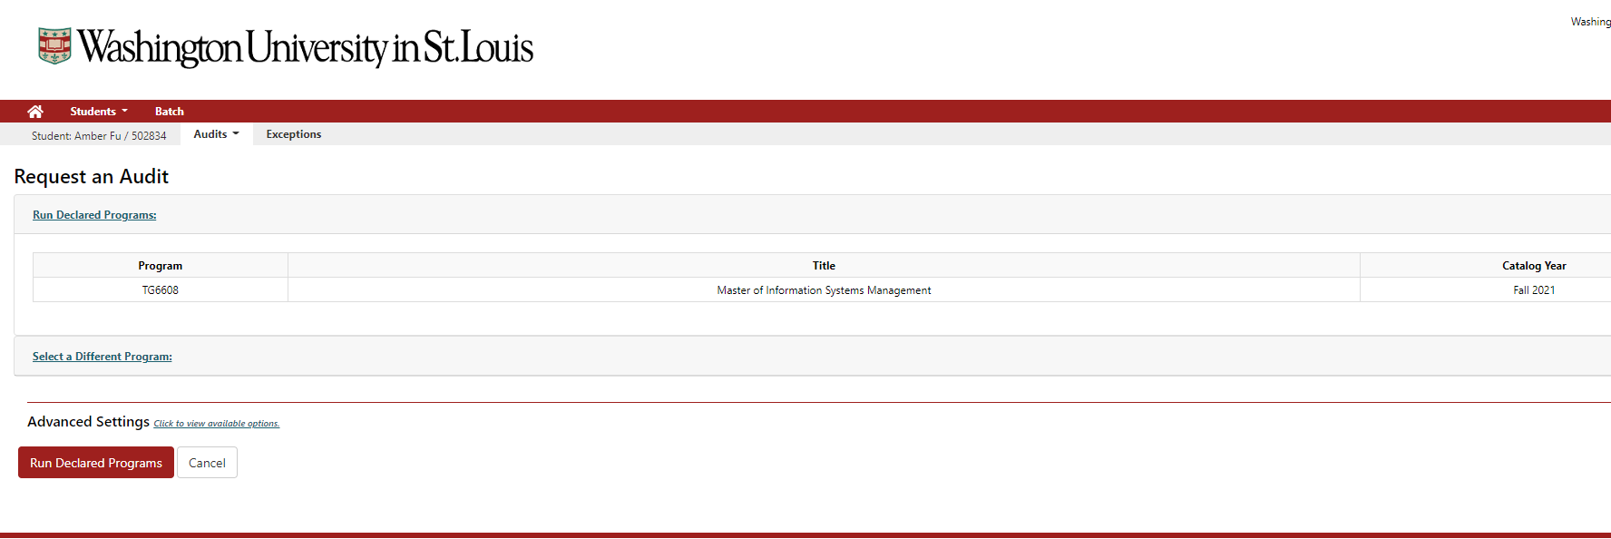

Click on the most recent audit at the top right
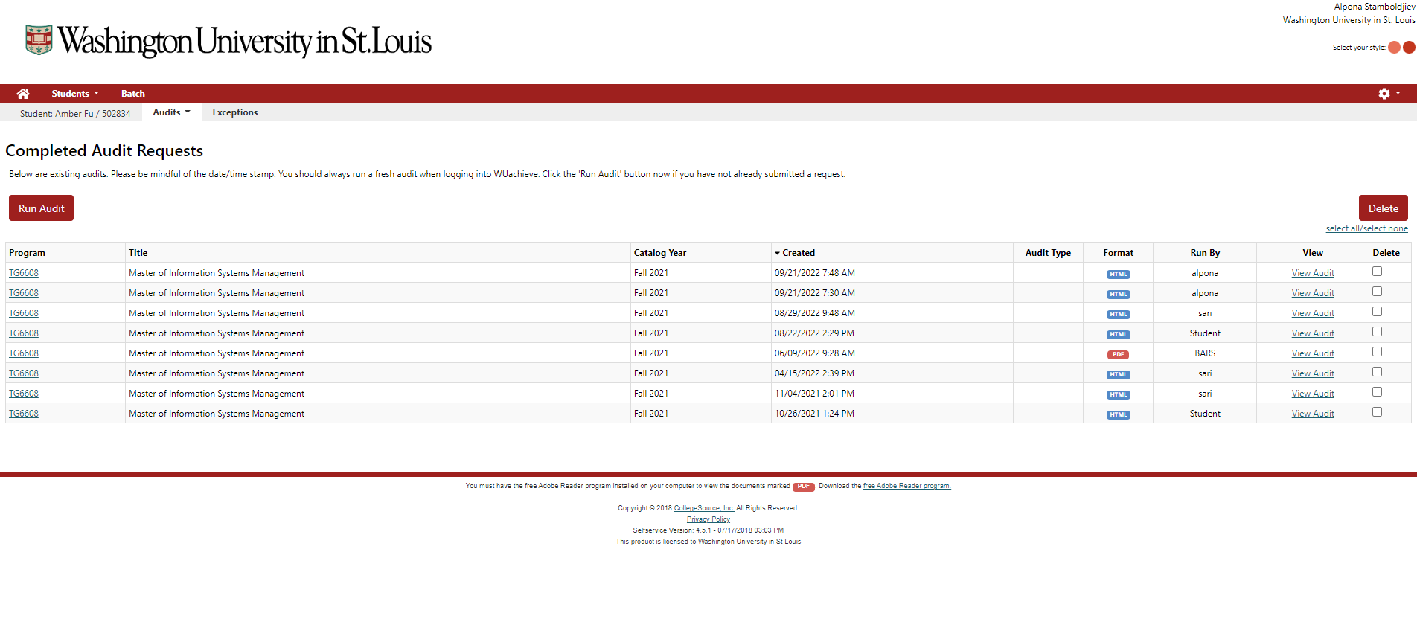

Click on “Open all sections”
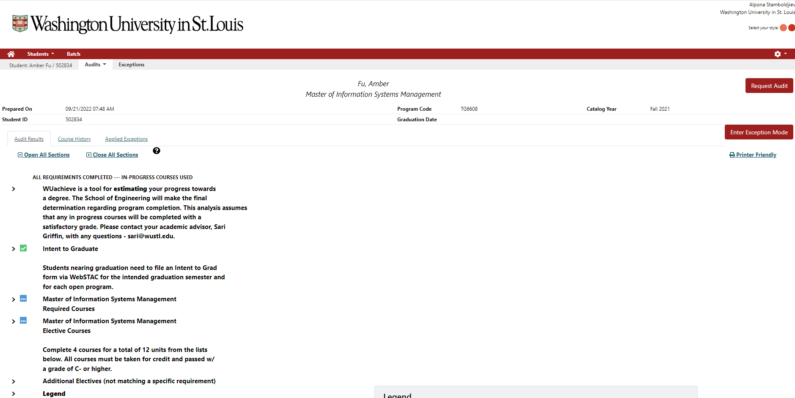

You will be able to view sections with your required and elective classes for degree completion. This is a handy tool to monitor your progress through your degree.
